**PROJECT REPORT**

ON

HOSPITAL MANAGENMENT

Submitted by: Rachit Yadav

Class : 12th-B

Roll no. :51

**[UNDER THE GUIDANCE OF**

**MS. P.DEEPTI(HOD)]**

**CERTIFICATE**

This is to certify that **RACHIT YADAV** of class XII-B has successfully completed the project work under guidance of Ms. P.Deepti. He has done his work all in original and finished it in due course of time as per CBSE guidelines.

**NAME: RACHIT YADAV**

**Class: XII B**

**Section: B (SCIENCE)**

**HOD Principal**

**Ms. P.Deepti MS. Monika Mehan**

**ACKNOWLEDGEMENT**

Me and my groupmates have tried our best to do on this project . however developing software is complex it requires professional help and at some places help from internet is also taken

I would like to thank to my teammates, we each have contributed to finish this project at its best and also to my teacher **Ms. P. Deepti** to help us at certain area we need to make our project amazing

**CONTENT**

* Introduction
* MySQL program
* Python program
* OUTPUT Of MySQL and Python
* INTRODUCTION

We have made a program of hospital management in which patients can take appointment or cancel their coming appointment, details of doctor which doctor is available at the moment and who is not, medicine list and prescription, and keeping of a patient record and more….

MYSQL PROGRAM

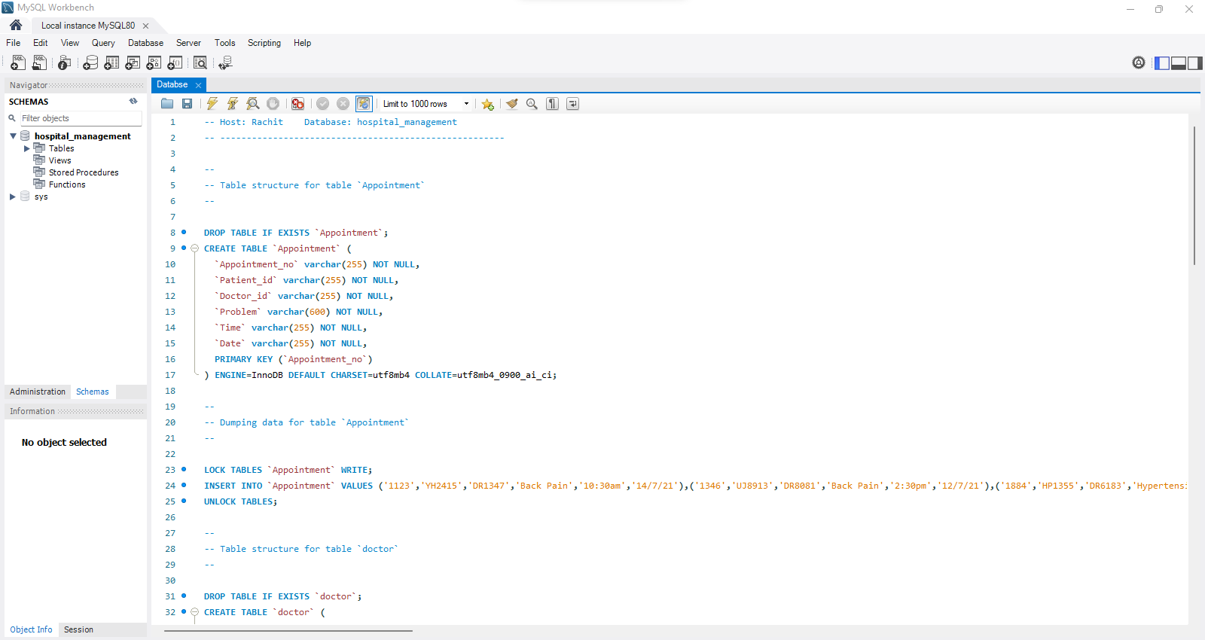

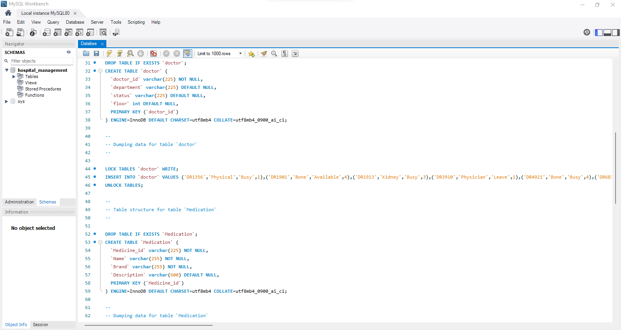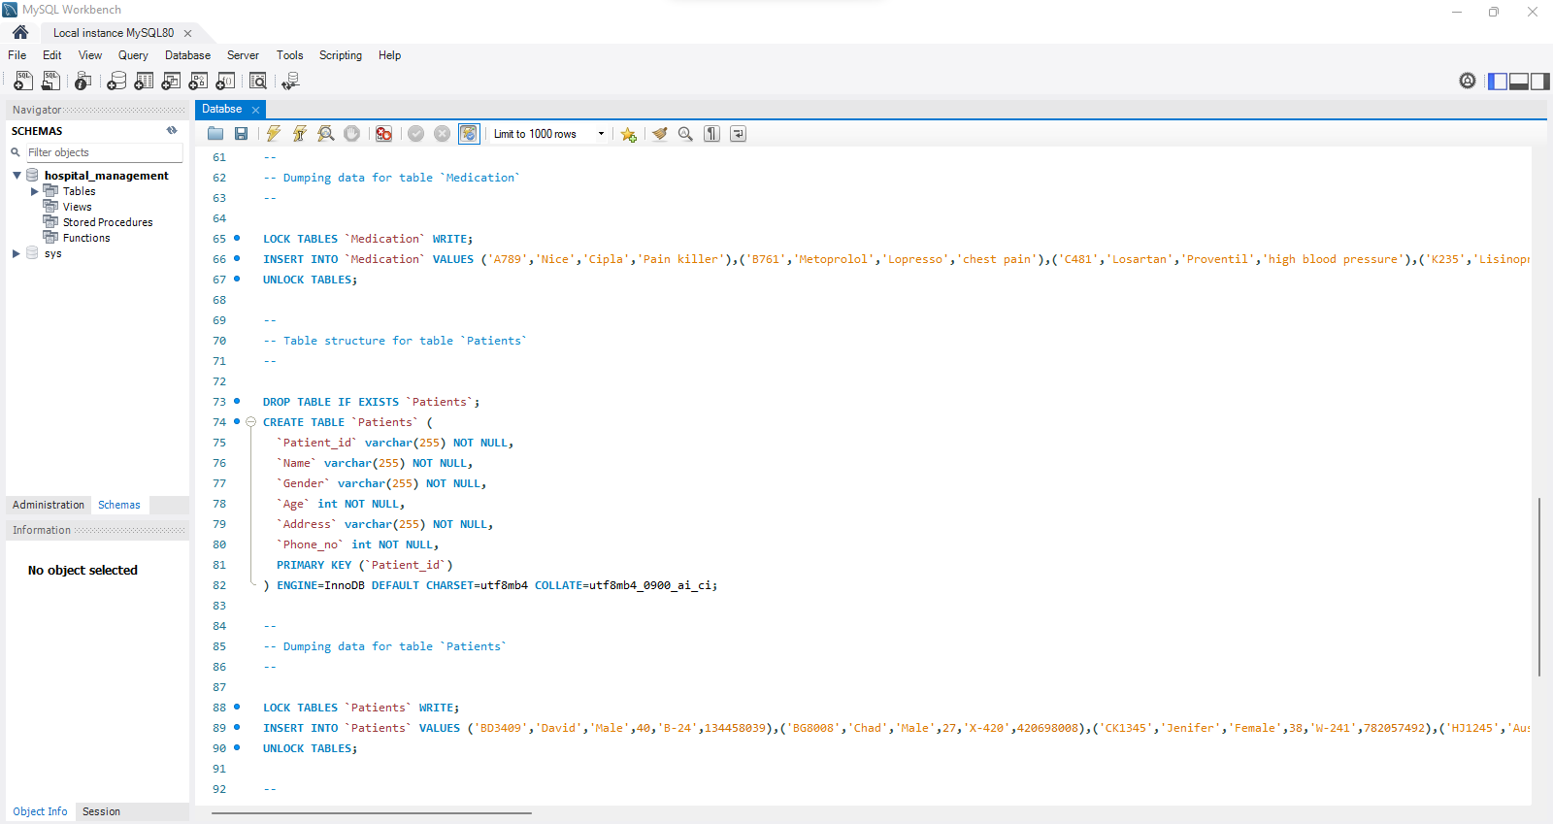

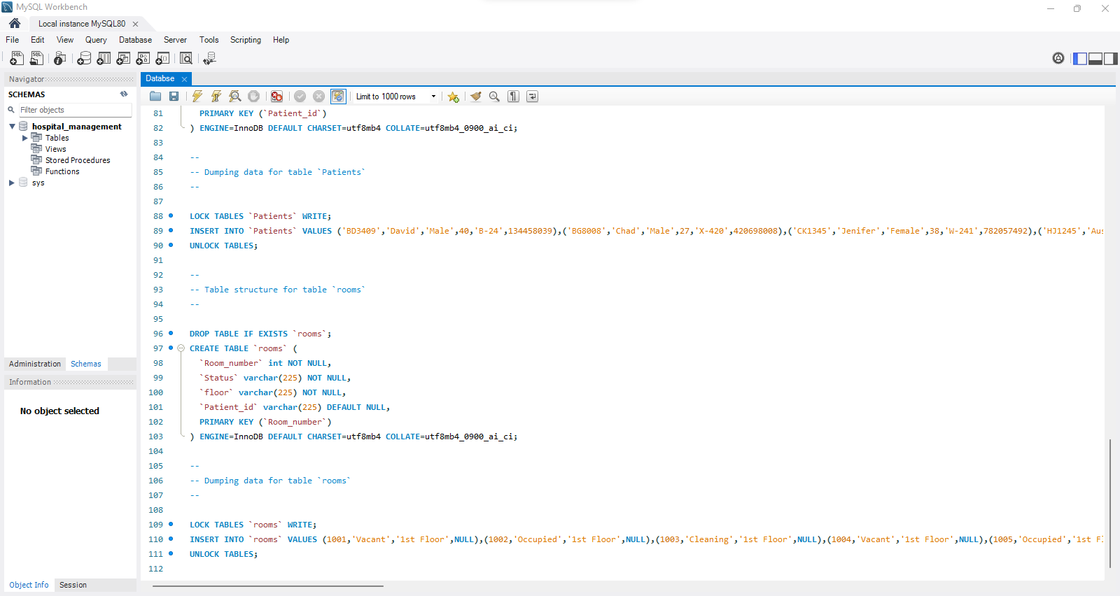

**Python program**

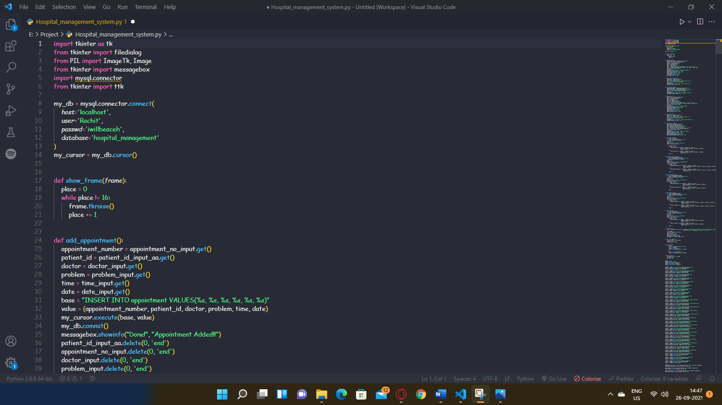

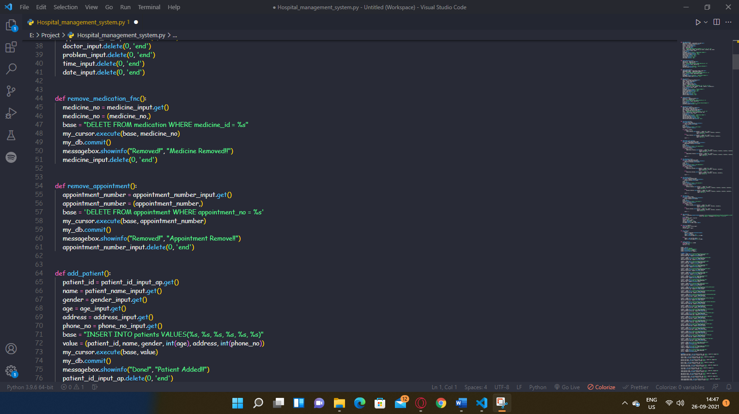

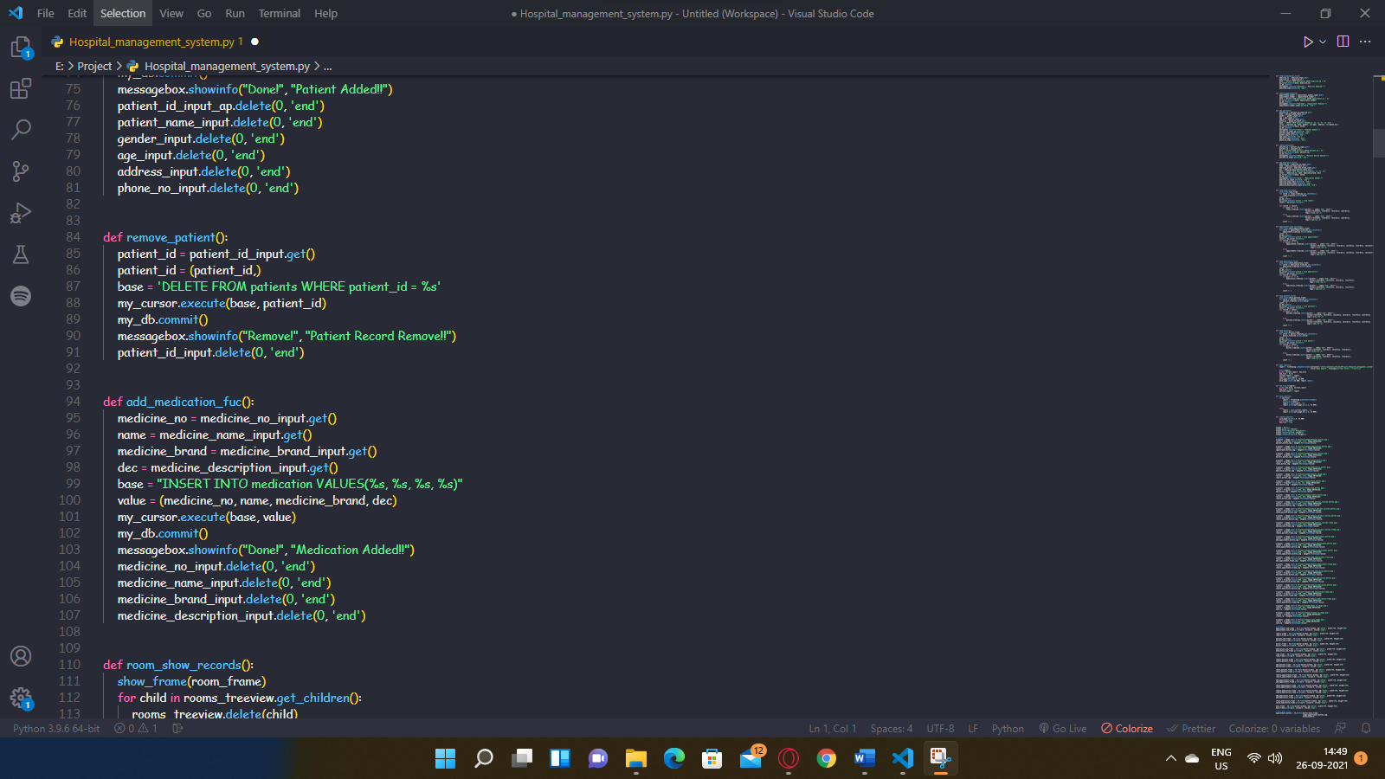

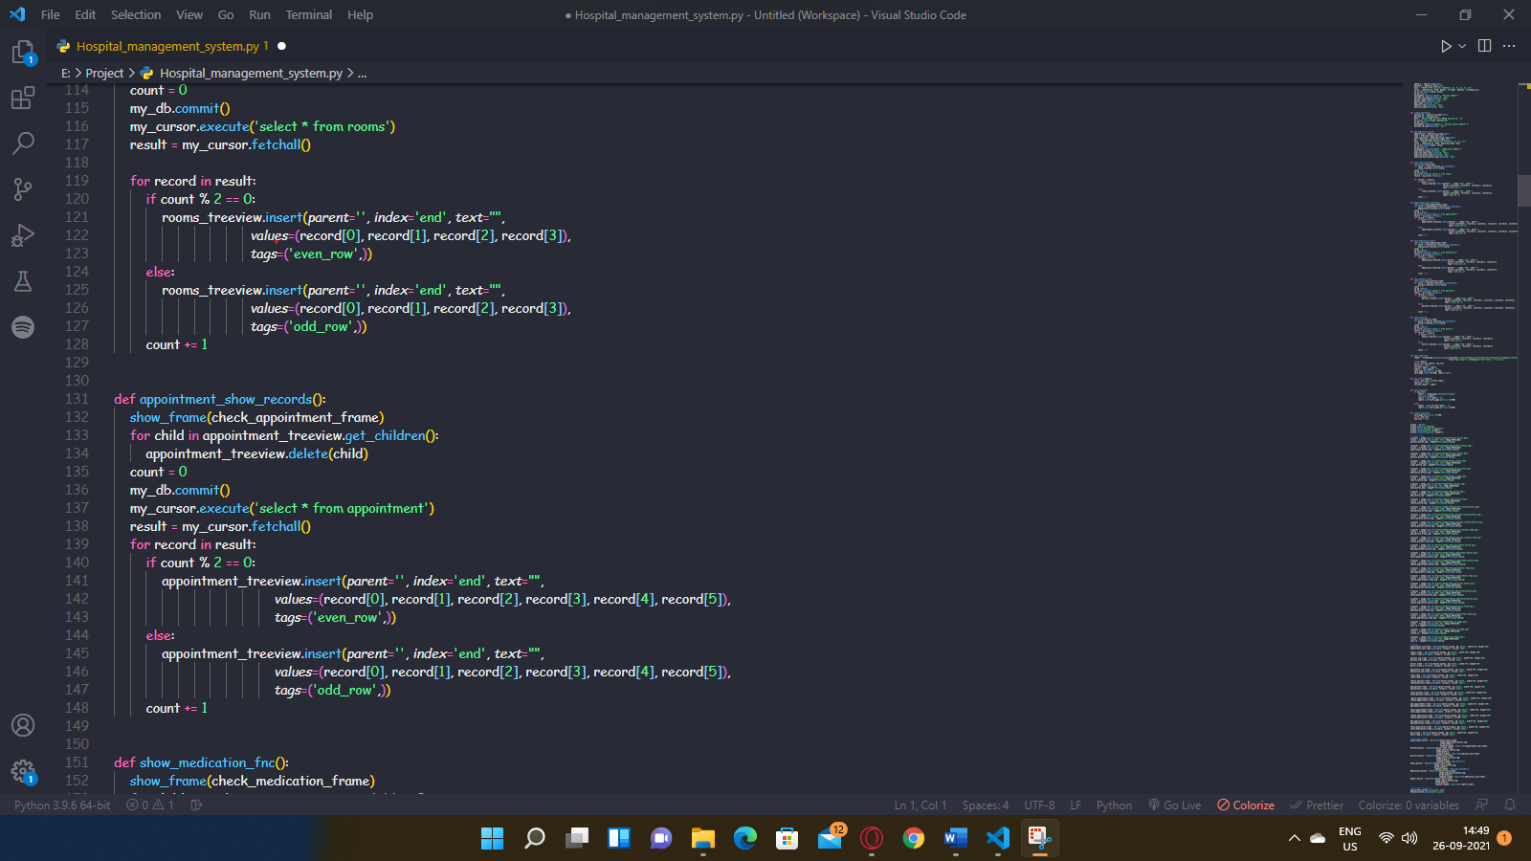

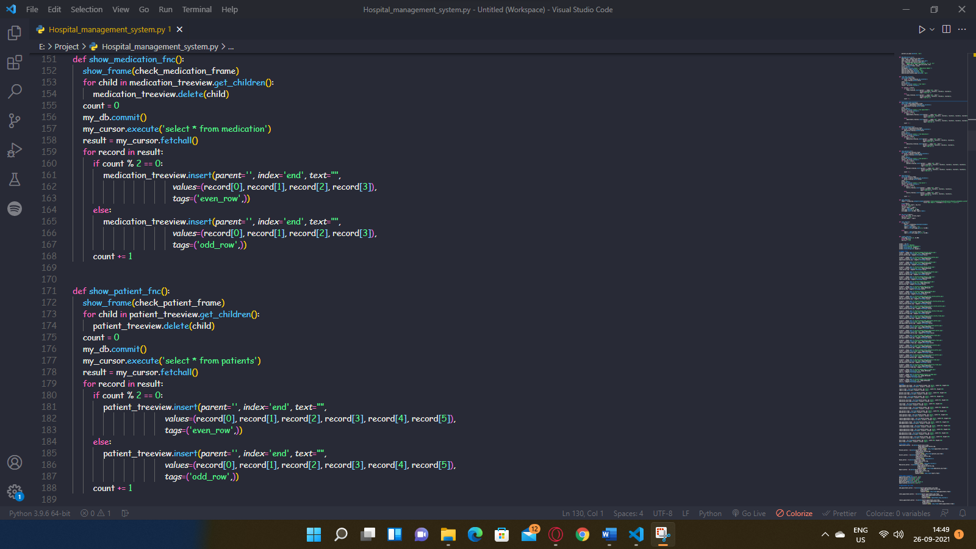

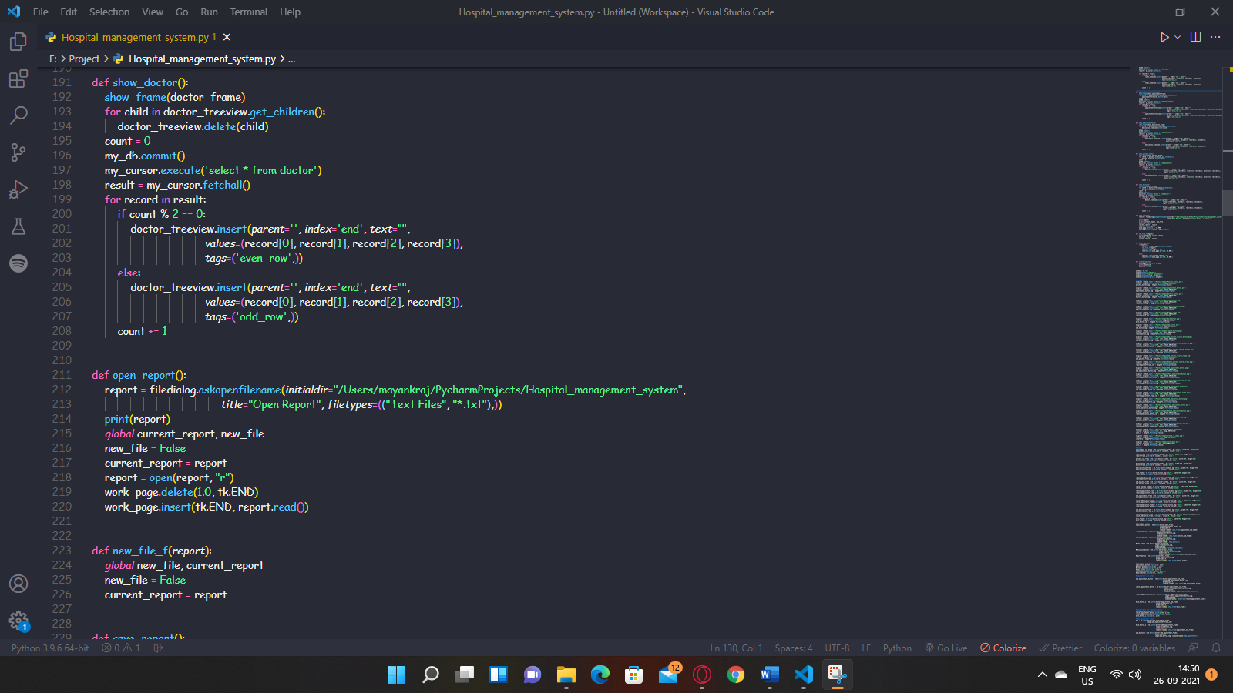

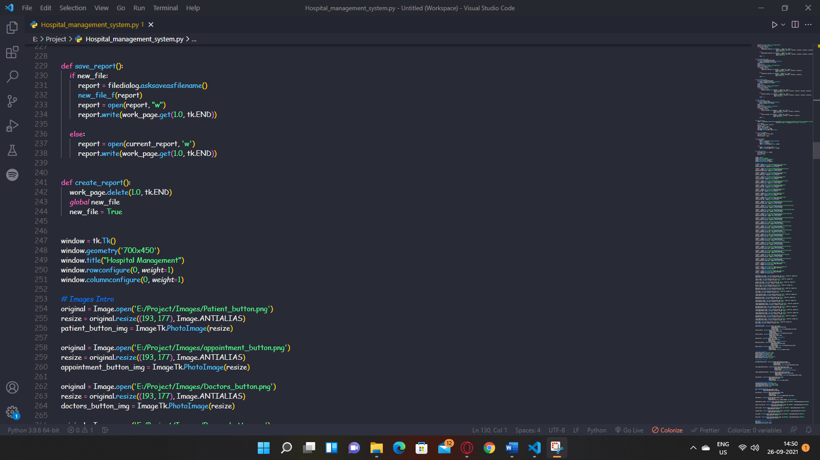

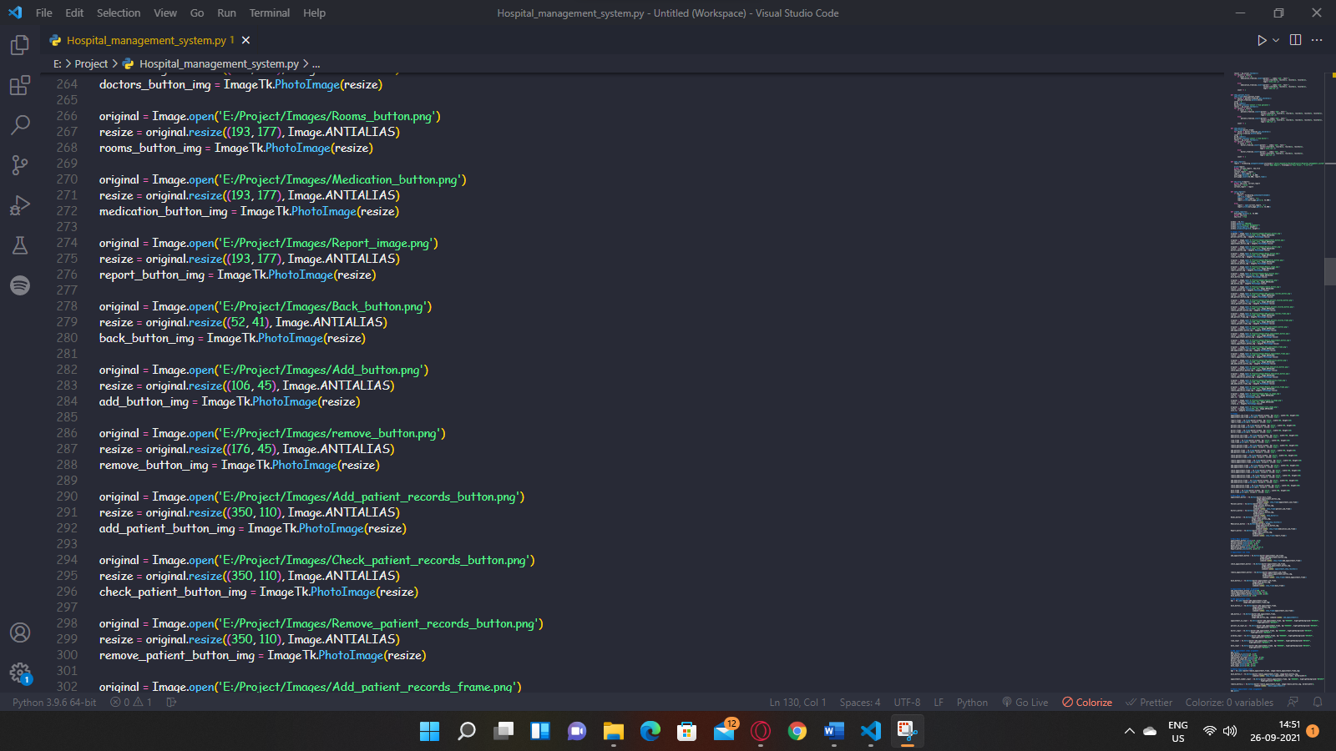

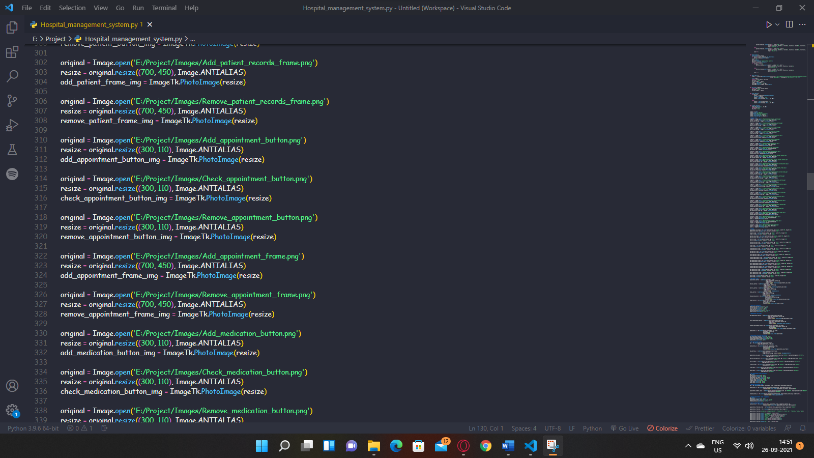

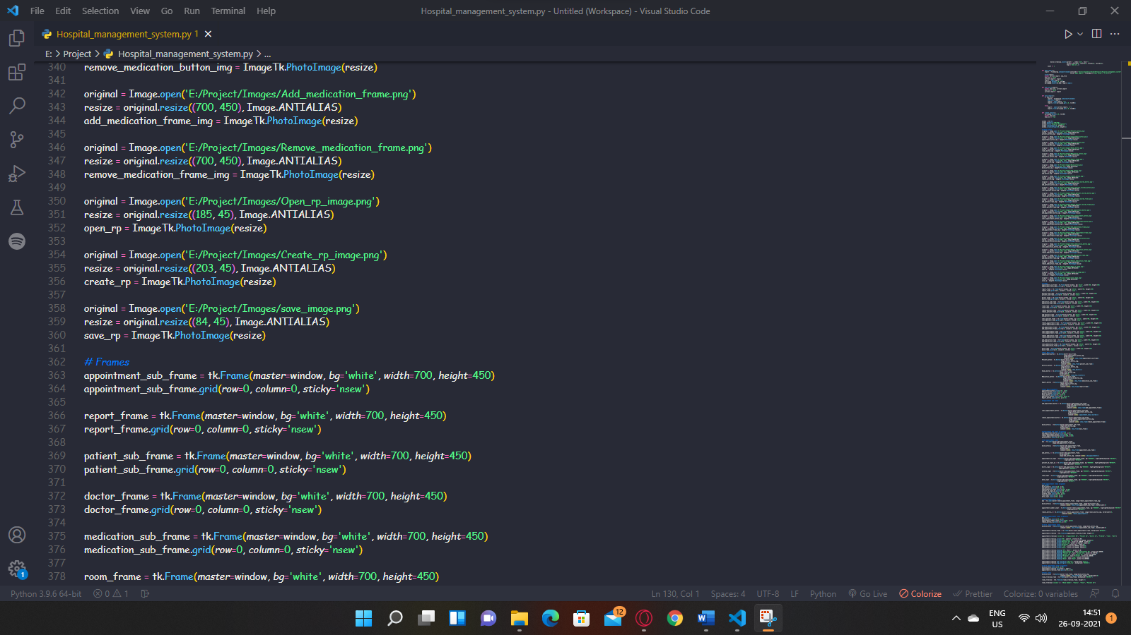

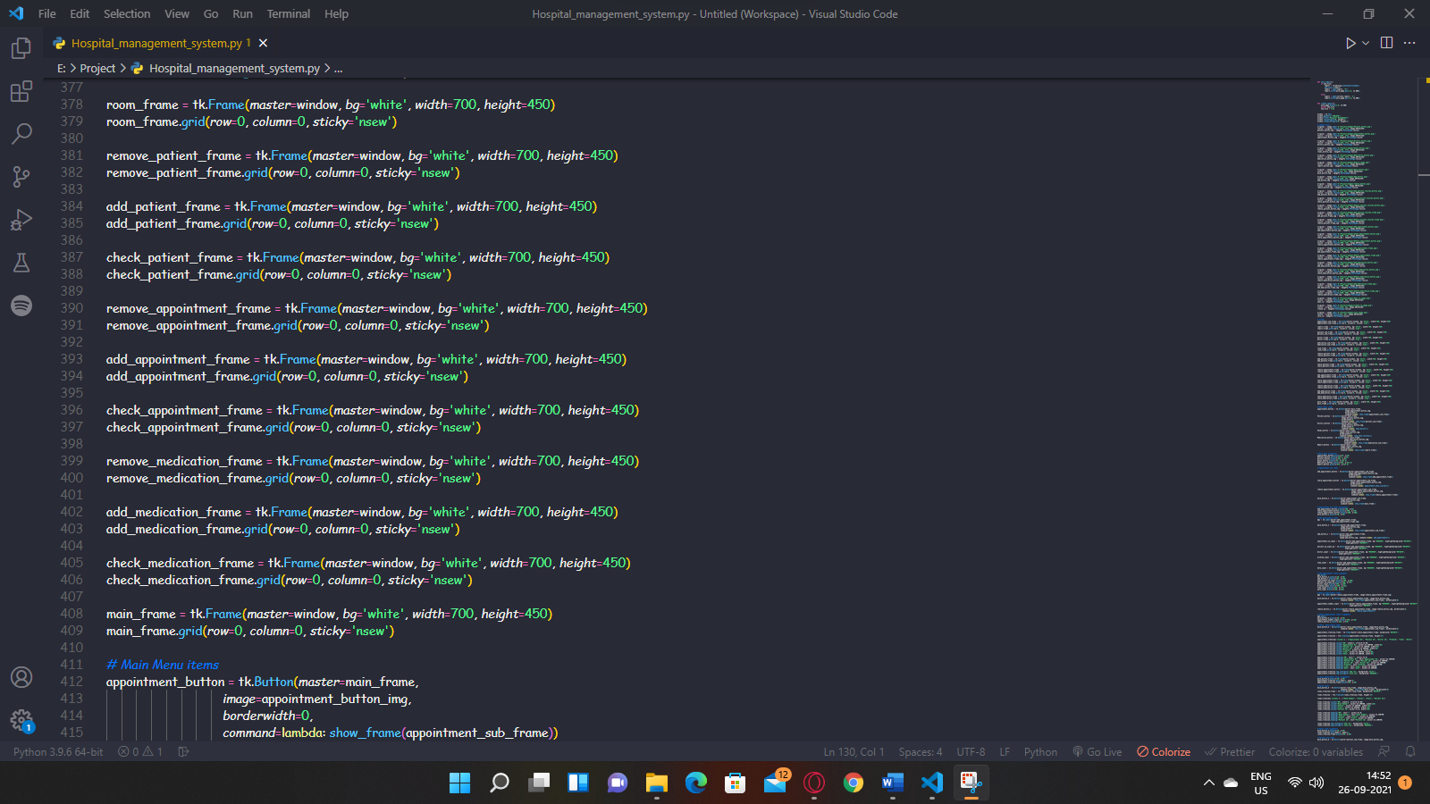

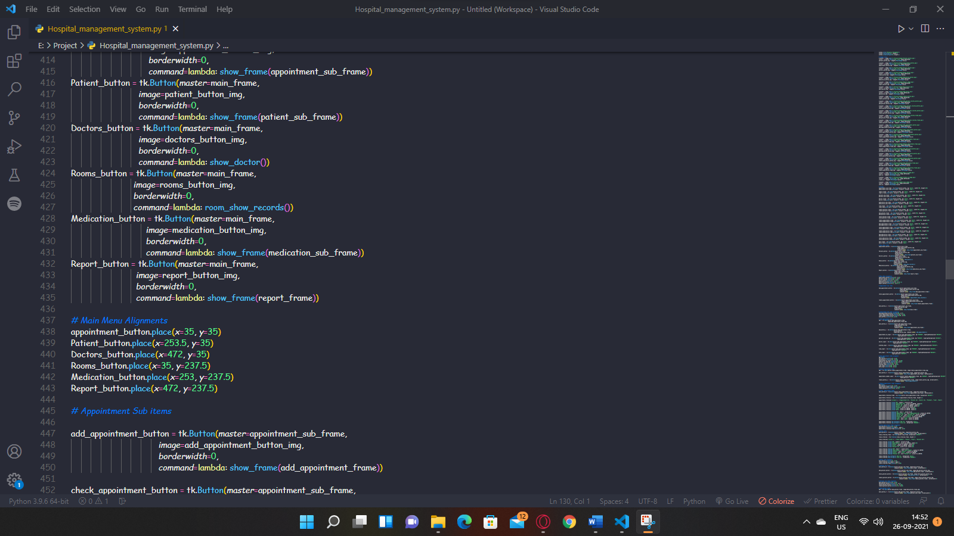

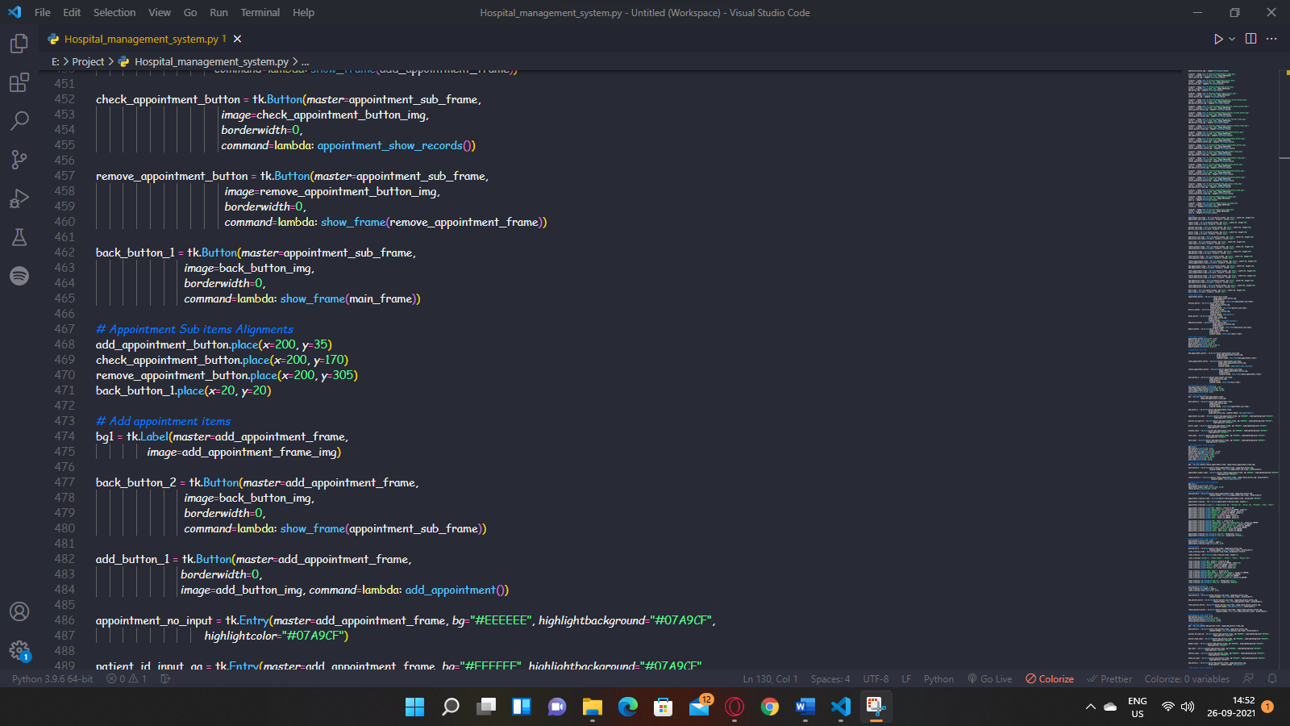

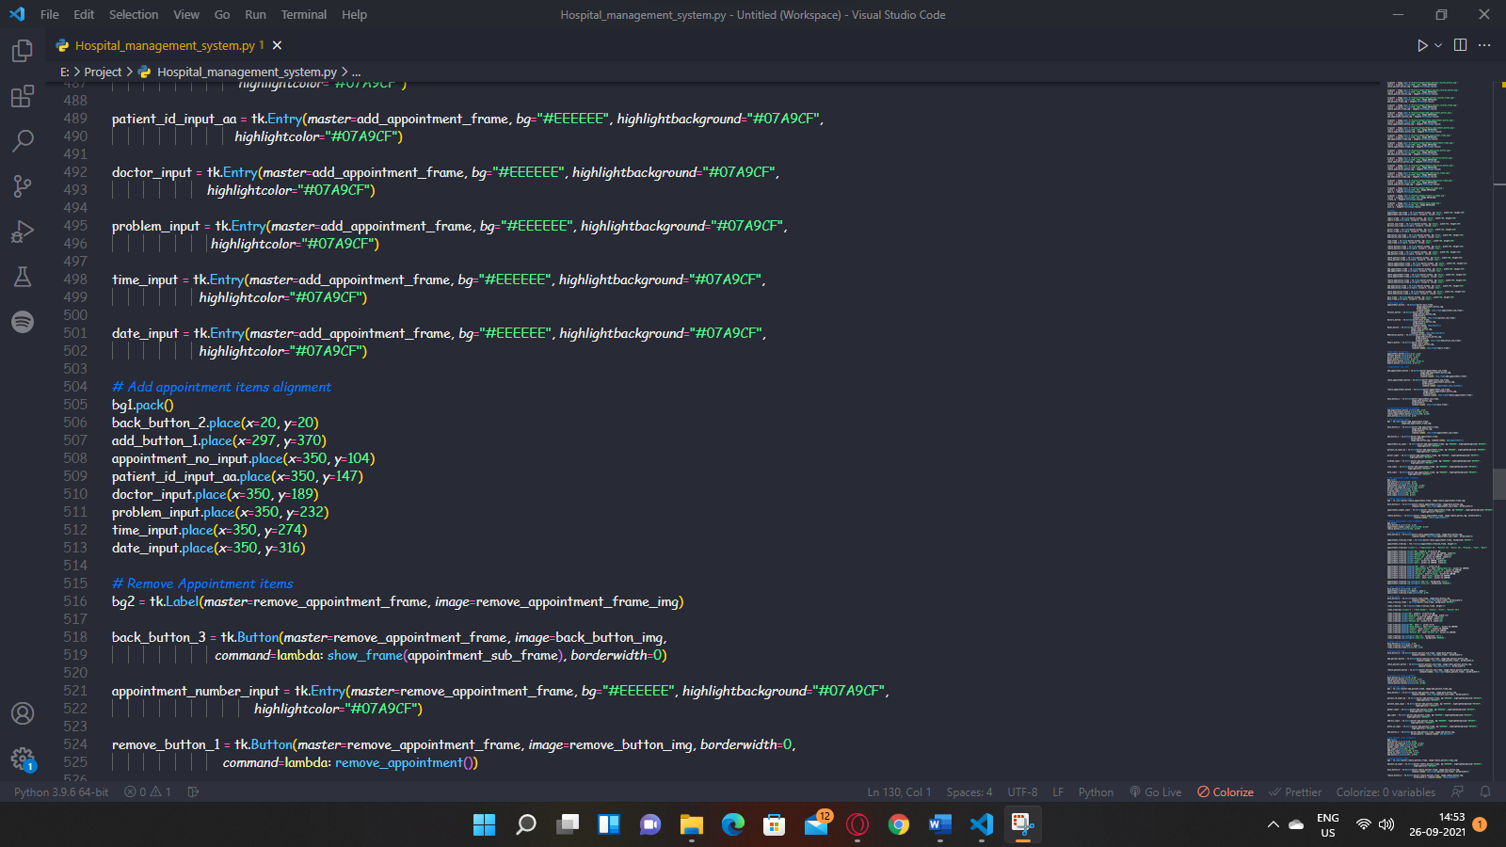

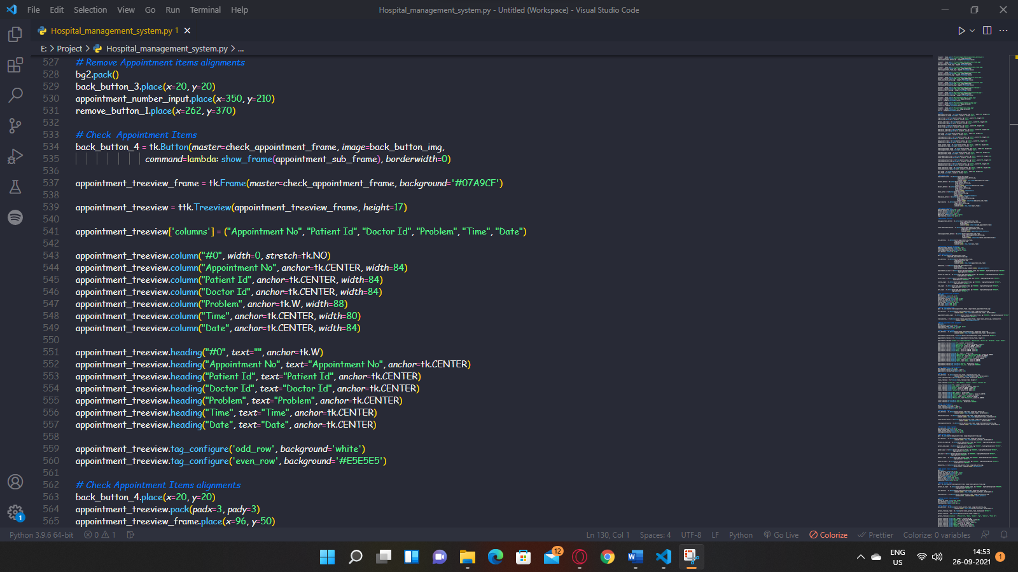

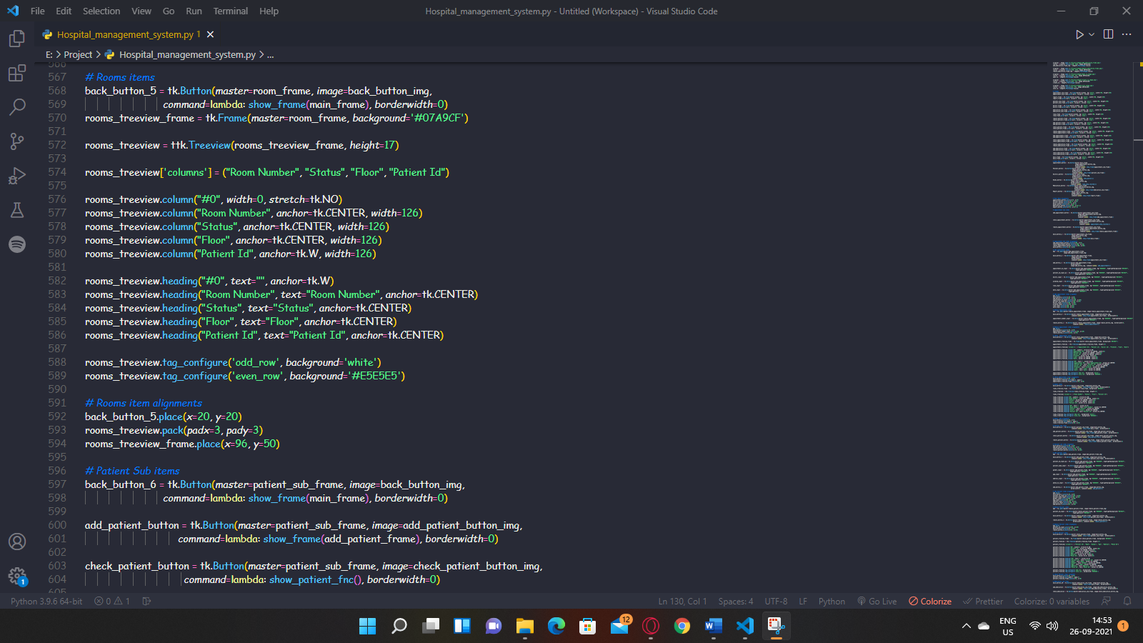

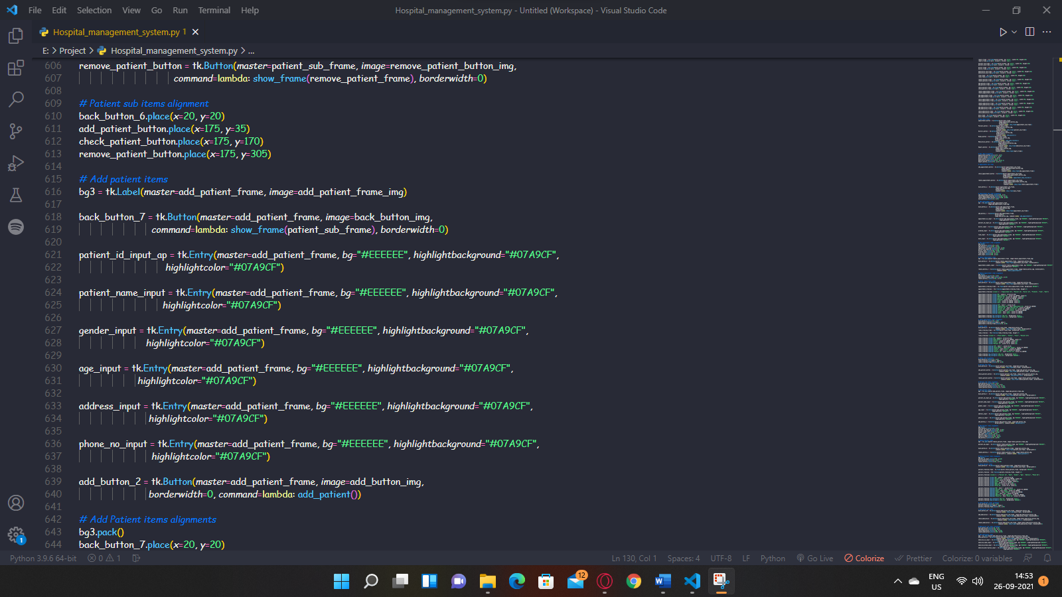

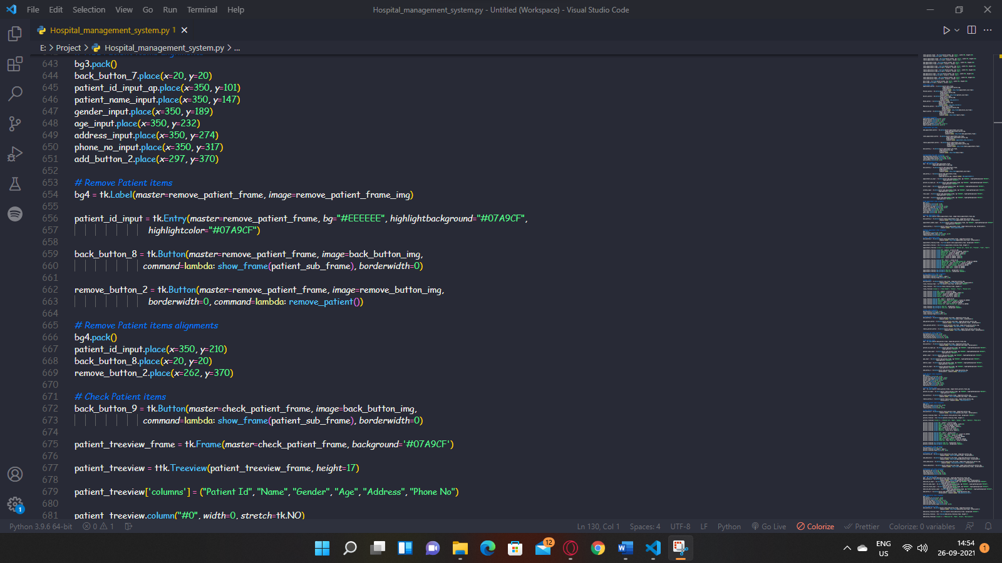

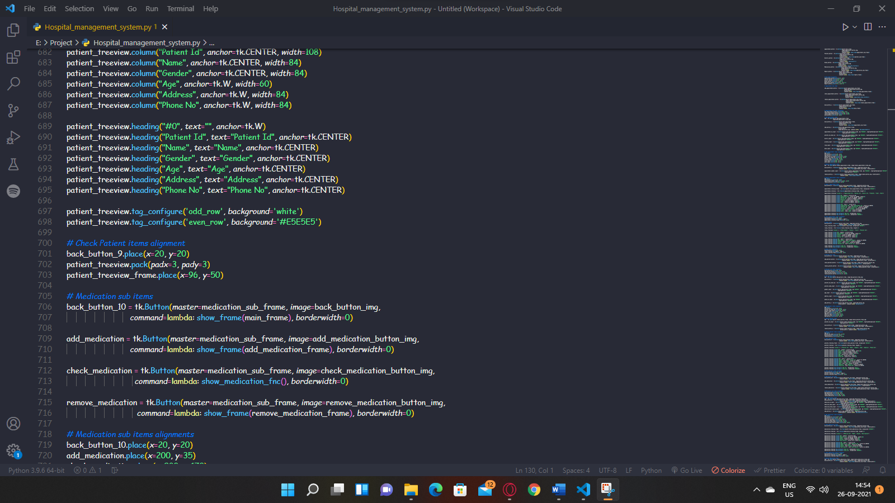

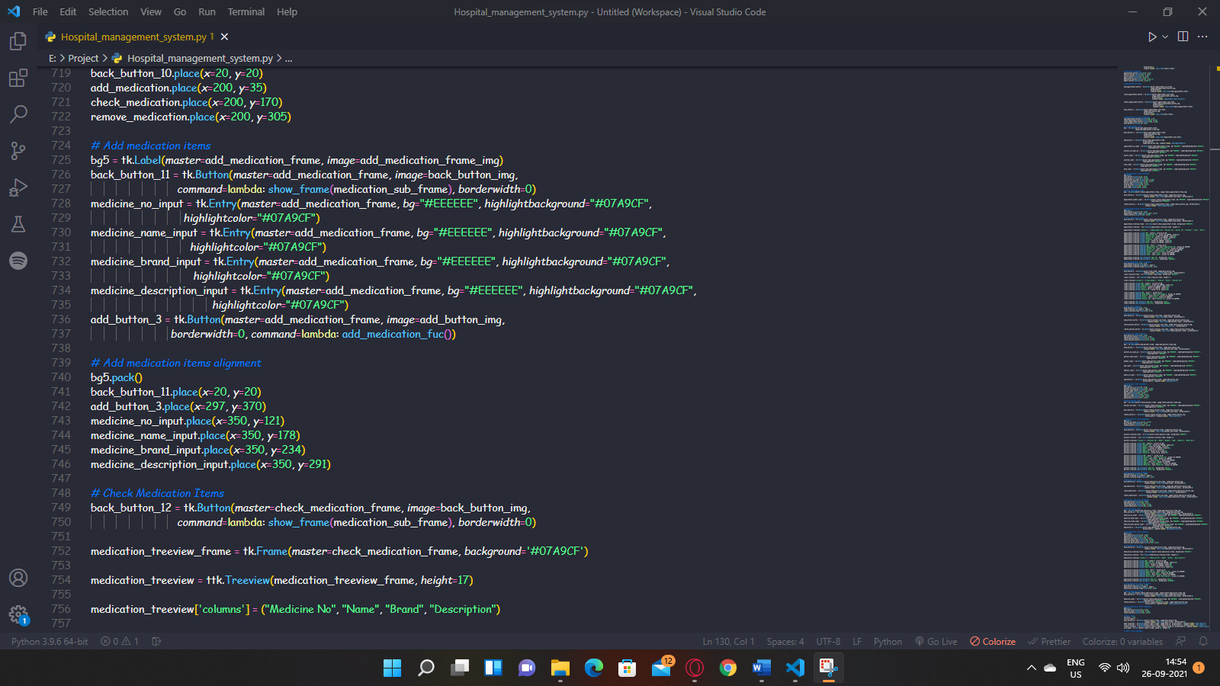

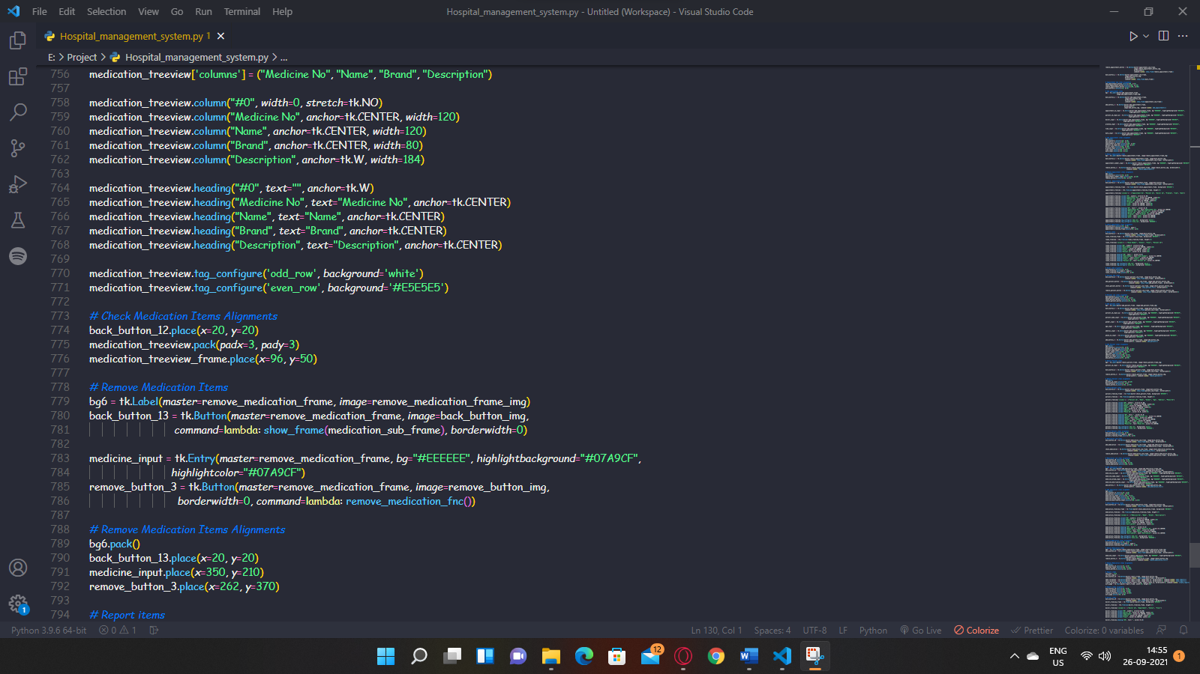

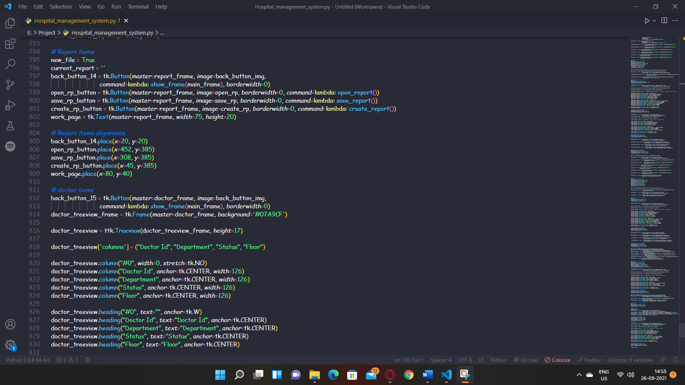

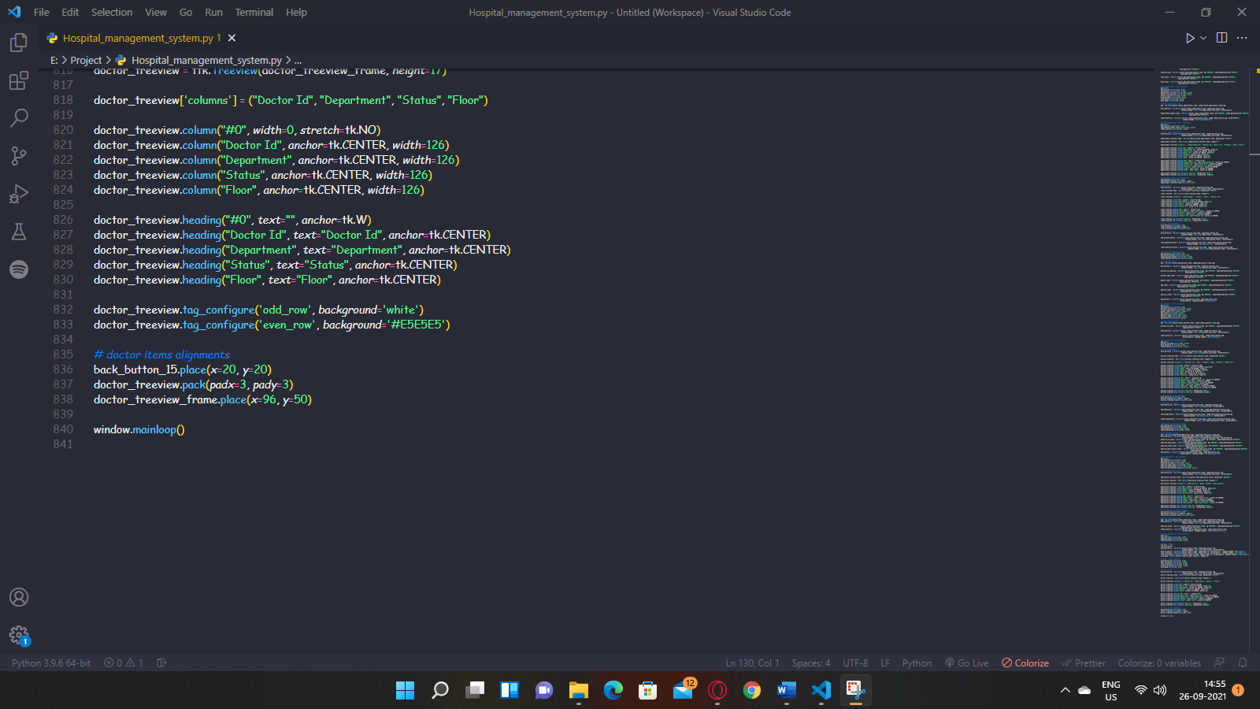

**DISPLAY OF OUR MANAGEMENT SYSTEM-GUI FORMAT**

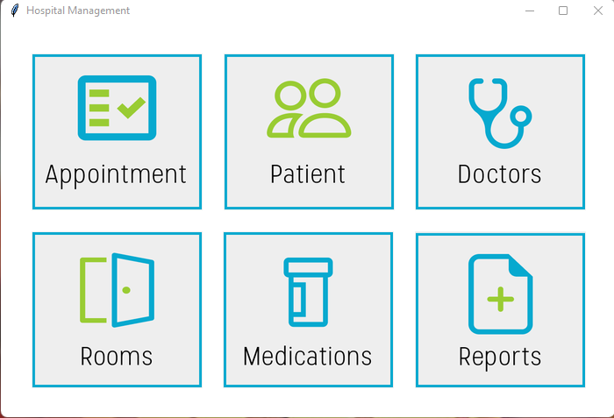

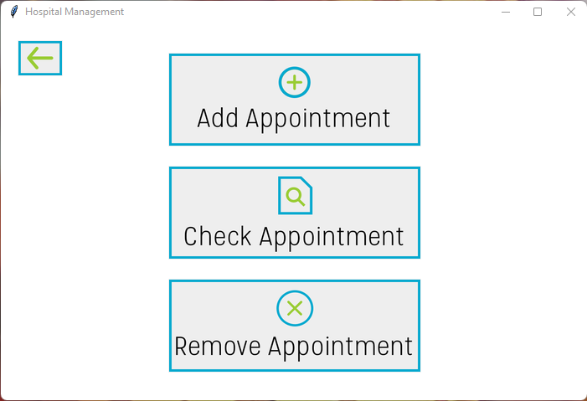

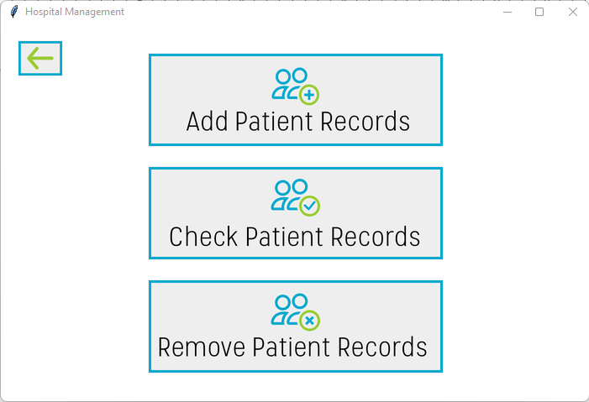

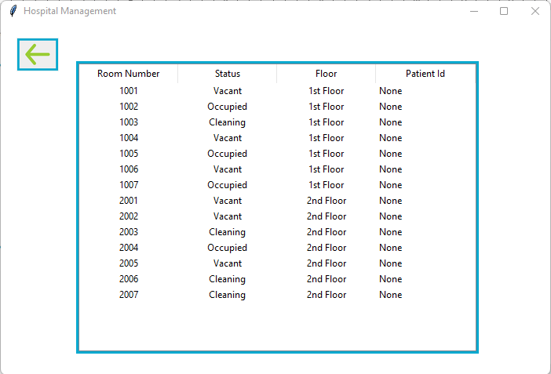

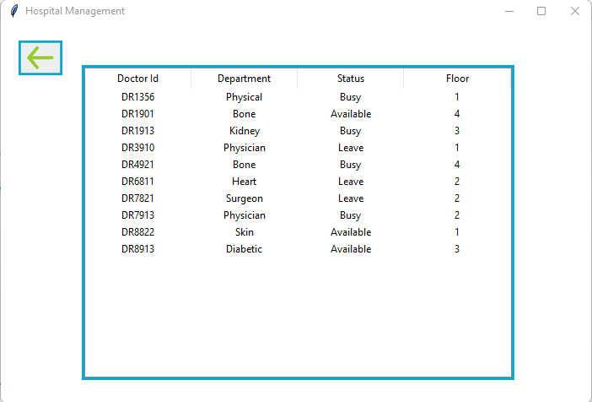

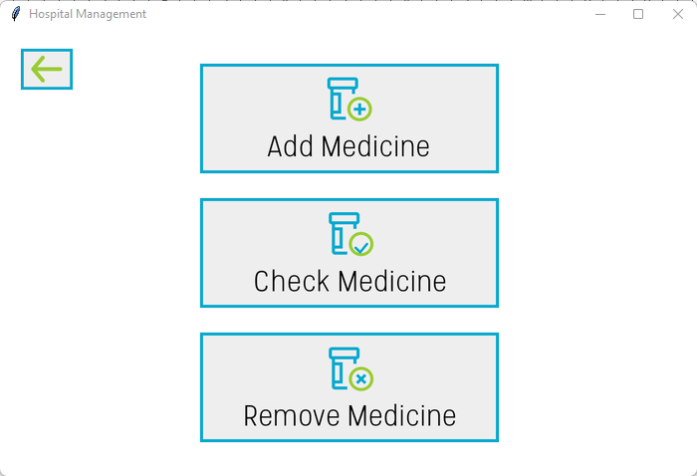

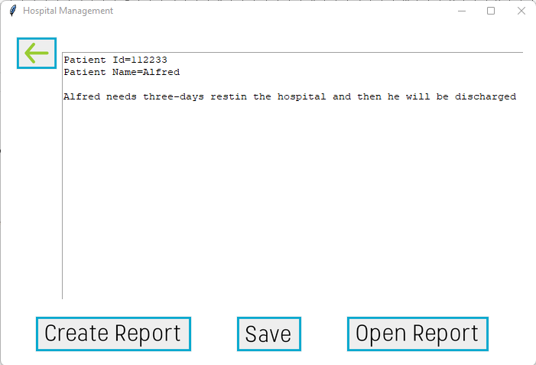

IMPORT .CSV FILE

Step 1: Prepare the CSV File

To begin, prepare the CSV file that you'd like to import to MySQL

Step 2: Import the CSV File into the DataFrame.

Next, import the CSV file into Python using the pandas library.

Step 3 : Connect to the MySQL using Python and create a Database

Create a connection object to connect to MySQL, The connect() constructor creates a connection to the MySQL and returns a MySQLConnection object

